

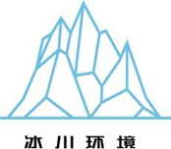
MADAGASCAR FAHATOKIANA IMPROVED COOKSTOVE PROGRAM
Document Prepared by Guangzhou Iceberg Environmental Consulting Services Co., Ltd.

Project title | Madagascar Fahatokiana Improved Cookstove Program
Project ID | 3239
Monitoring period | 06/08/2022 to 05/08/2024
Original date of issue | DD-Month-YYYY is the date the monitoring report was completed following the completion of the audit.
Most recent date of issue | DD-Month-YYYY is the date on which the document was most recently submitted
Version | 01
VCS Standard Version | VCS Standard Version 4.4
Prepared by | Guangzhou Iceberg Environmental Consulting Services Co., Ltd.

Contents

1 Project Details 4
1.1 Summary Description of the Implementation Status of the Project 4
1.2 Audit History 4
1.3 Sectoral Scope and Project Type 5
1.4 Project Proponent 5
1.5 Other Entities Involved in the Project 5
1.6 Project Start Date 5
1.7 Project Crediting Period 5
1.8 Project Location 6
1.9 Title and Reference of Methodology 7
1.10 Double Counting and Participation under Other GHG Programs 7
1.11 Double Claiming, Other Forms of Credit, and Scope 3 Emissions 7
1.12 Sustainable Development Contributions 8
1.13 Commercially Sensitive Information 13
2 Safeguards and Stakeholder Engagement 13
2.1 Stakeholder Engagement and Consultation 13
2.2 Risks to Stakeholders and the Environment 16
2.3 Respect for Human Rights and Equity 17
2.4 Ecosystem Health 18
3 Implementation Status 19
3.1 Implementation Status of the Project Activity 19
3.2 Deviations 19
3.3 Grouped Projects 19
3.4 Baseline Reassessment 19
4 Data and Parameters 19
4.1 Data and Parameters Available at Validation 20
4.2 Data and Parameters Monitored 22
4.3 Monitoring Plan 26
5 Quantification of GHG Emission Reductions and Removals 30
5.1 Baseline Emissions 30
5.2 Project Emissions 30
5.3 Leakage Emissions 30
5.4 GHG Emission Reductions and Carbon Dioxide Removals 30
APPENDIX 1: STATEMENT ABOUT OUTCOMES OF SDGS 35

Project Details

Summary Description of the Implementation Status of the Project
The project involves distribution of fuel-efficient Fahatokiana improved cookstoves (hereinafter referred to as “ICSs”) in the Republic of Madagascar. The ICSs disseminated through this project replace the old low efficient baseline cookstoves in rural area of Madagascar. The ICSs are produced by local factories.
Through this project, Guangzhou Iceberg Environmental Consulting Services Co., Ltd. (hereinafter referred to as “Iceberg”) plans distribute approximately 100,000 ICSs free of charge to households in rural area of Madagascar in 2 years. The start date of the project was 06/08/2022. 24,696 ICSs have been distributed till 05/08/2024, and 24,232 are still operating according to the monitoring survey.
Before the implementation of the project, local people mostly used traditional solid-fuel cooking solutions such as open fire or three-stone fires. They spent plenty of time to collect firewood every day due to low combustion efficiency of baseline cooking devices. The ICS burnt wood more efficiently thereby improving thermal transfer to pots, hence saving firewood. The project has reduced the GHG emission by less non-renewable firewood combustion as well as slowing the rapidly progressing deforestation in Madagascar.
Iceberg cooperates with local partners to ensure that the ICSs reach the target communities. The local partners are in charge of the distribution. They help Iceberg to gain access to the communities and identify local suppliers. Iceberg has provided enough training to the local partners to ensure that they can implement the project smoothly. The distribution has been on-site supervised by Iceberg. All data are collected by online system.
The crediting period of the project is expected to be 10 years. The average annual GHG emission reduction from the project is expected to be 481,597 tCO₂e. The total GHG emission reduction is 4,815,976 tCO₂e. This monitoring period is the first one, which is from 06/08/2022 to 05/08/2024. The GHG emission reduction of this monitoring period from the project is 162,449 tCO₂e.

Audit History
Audit type | Period | Program | Validation/verification body name | Number of years
Validation/ verification | 06/08/2022—05/08/2024 | VCS | Validation/verification body name | Two years

Sectoral Scope and Project Type
Sectoral scope | 03 - Energy demand
Project activity type | II – Energy efficiency improvement projects

Project Proponent
Organization name | Guangzhou Iceberg Environmental Consulting Services Co., Ltd.
Contact person | Ji BAO
Title | General Manager
Address | No.106 Fengze East Road, Nansha District, Guangzhou, China
Telephone | +8613560420840
Email | baoji@icebergchina.com; hanjin@icebergchina.com

Other Entities Involved in the Project
No other entities involved. The Project proponent is the only entity which is in charge of the project.

Project Start Date
Project start date | 06/08/2022
Justification | The date of the first installation of the project ICS, which is the date on which the project began generating GHG emission reductions.

Project Crediting Period
Crediting period | ☐ Seven years, twice renewable  ☒ Ten years, fixed  ☐ Other (state the selected crediting period and justify how it conforms with the VCS Program requirements)
Start and end date of first or fixed crediting period | 06/08/2022 to 05/08/2032

Project Location
The project location is in the Republic of Madagascar.
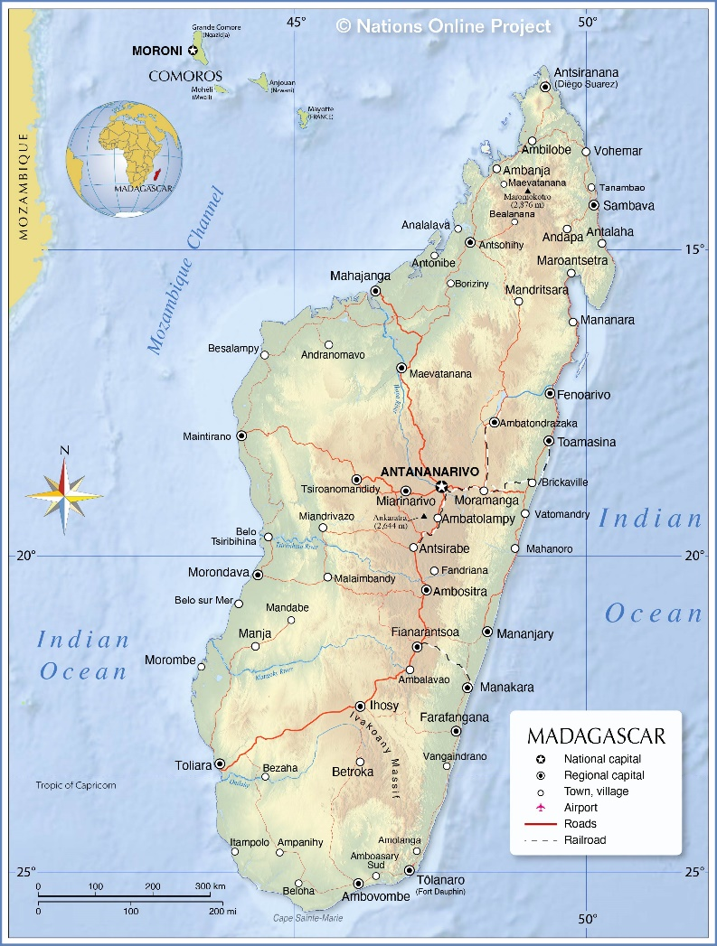
Table 1: Geographical coordinates of the Republic of Madagascar
Orientation | Latitude | Longitude
Eastmost | 15°20′16″ S | 50°32′28″ E
Westmost | 22°10′30″ S | 43°13′24″ E
Southmost | 25°35′19″ S | 45°10′19″ E
Northmost | 12°09′49″ S | 49°16′32″ E
Figure 1: Map of the Republic of Madagascar

Title and Reference of Methodology
Type (methodology, tool or module). | Reference ID, if applicable | Title | Version
Methodology | VMR0006 | VMR0006 Methodology for Installation of High Efficiency Firewood Cookstoves | 1.1
Tool | 30 | TOOL30 Calculation of the fraction of non-renewable biomass | 3.0

Double Counting and Participation under Other GHG Programs

No Double Issuance
Is the project receiving or seeking credit for reductions and removals from a project activity under another GHG program?
☐ Yes ☒ No

Registration in Other GHG Programs
Is the project registered or seeking registration under any other GHG programs?
☐ Yes ☒ No

Double Claiming, Other Forms of Credit, and Scope 3 Emissions

No Double Claiming with Emissions Trading Programs or Binding Emission Limits
Are project reductions and removals or project activities also included in an emissions trading program or binding emission limit? See the VCS Program Definitions for definitions of emissions trading program and binding emission limit.
☐ Yes ☒ No

No Double Claiming with Other Forms of Environmental Credit
Has the project activity sought, received, or is planning to receive credit from another GHG-related environmental credit system? See the VCS Program Definitions for definition of GHG-related environmental credit system.
☐ Yes ☒ No

Supply Chain (Scope 3) Emissions
Do the project activities affect the emissions footprint of any product(s) (goods or services) that are part of a supply chain?
☒ Yes ☐ No
Is the project proponent(s) or authorized representative a buyer or seller of the product(s) (goods or services) that are part of a supply chain?
☒ Yes ☐ No
Has the project proponent(s) or authorized representative posted a public statement on their website saying, “Carbon credits may be issued through the Verified Carbon Standard project [project ID] for the greenhouse gas emission reductions or removals associated with [project proponent or authorized representative organization name(s)] [name of product(s) whose emissions footprint is changed by the project activities].”
☒ Yes ☐ No
The project proponent has posted a public statement on their website, the link of the website is: http://www.icebergchina.com/ensnew/contents/304/116.html .

Sustainable Development Contributions
Before the implementation of the project, local people in the project location used non-renewable biomass for cooking with three-stone fire or used conventional stove without grate or chimney before the project implemented. The project distributes fuel-efficient ICS to replace the baseline cookstoves in households, which leads to less firewood consumption, and reduces people’s exposure to hazardous indoor air. Hence people spend less time to collect firewood which reduces women and children’s drudgery. The production and distribution of ICSs have provided job opportunities to local people which will increase their incomes. And the project contributes to less deforestation and less GHG emissions too.

Table 1: Sustainable Development Contributions
Row number | SDG target | SDG indicator | Net impact on SDG indicator | Current project contributions | Contributions over project lifetime
1) | 1.4 | Project-specific indicator:  Number of households with access to basic services | Implemented activities to increase | 24,696 households have received ICSs, and 24,232 are still operating. | Improved cookstove is a basic service necessary to lead a healthy and productive life, including saving time and money for wood fuel at the household level. The project proponent will distribute 100,000 ICSs to end users free, which will save their money on buying them.
2) | 2.1 | 2.1.1 Prevalence of undernourishment. | Implemented activities to decrease | 24,696 households have received ICSs, and 24,232 are still operating, which help them improve their nutrition status. | Vulnerable populations often face significant risks to their health and nutrition due to inadequate access to the means of cooking their food, the project will improve food security and nutrition status for people in rural area of Madagascar by reducing inadequate cooking due to fuel-saving cooking practices.
3) | 3.9 | Project-specific indicator:  Number of households experiencing health benefits due to reduced exposure to indoor air pollution | Implemented activities to decrease | By using ICS, all users admitted that the project cookstove had improved indoor air quality and reduced air quality related diseases, like cough or trachitis according to the monitoring survey. Thus, 24,232 households experiencing health benefits due to reduced exposure to indoor air pollution. | By using ICS, it will reduce people’s exposure to high PM2.5 and high CO due to higher efficiency of combustion leading to faster cooking and more complete combustion.
4) | 4.3 | Project specific indicator:  Number of persons who received any informal training | Implemented activities to increase | About 2 staff have received training about the survey method and monitoring plan etc. | The project proponent has provided and will provide vocational and relevant skills to local people non-formal education and training on issues related to climate change. The staff hired for the implementation of the project have been trained with skills in operations and surveying activities related to stove distribution and its monitoring under VCS.
5) | 5.4 | 5.4.1 Proportion of time spent on unpaid domestic and care work, by sex, age, and location. | Implemented activities to decrease | The time spend on cooking and collecting firewood every day for women and girls who use ICSs has decreased about 29%. | The project will reduce women and children’s drudgery through time savings in reducing time spent on cutting, collecting, and carrying firewood from trees far away from households as well as cooking over toxic smoky open fires.
6) | 6.6 | Project specific indicator:  Quantity of non-renewable biomass in forest, which is a water-related ecosystem, saved by reducing fuel consumption | Implemented activities to increase | The project has saved 79,298.78 tonnes of non-renewable biomass during this monitoring period. | The project will save 235,089 tonnes of non-renewable biomass every year and it will result in a significant reduction of deforestation. Hence, it will protect the important water-related ecosystem.
7) | 7.1 | 7.1.2 Proportion of population with primary reliance on clean fuels and technology. | Implemented activities to increase | 24,696 households have received ICSs, and 24,232 are still operating, which are primary reliance on clean fuels and technology. | The ICS distributed to Household is a cleaner cooking technology. The project will increase the proportion of population with primary reliance on clean fuels and technology in project area.
8) | 8.3  8.5 | 8.3.1 Proportion of informal employment in total employment, by sector and sex.  8.5.1 Average hourly earnings of female and male employees, by occupation, age and persons with disabilities | Implemented activities to increase | 2 more local people have been hired after the implementation of the project. There are 12 full-time employee and 5 part-time employees now, and 8 of them are women, 3 are with disabilities. The average hour salary of full-time employee has increased from 0.22USD to 0.25USD.. | The manufacturer will hire more people for the implementation of the project, such as productions, transporting and distribution of related devices. Iceberg and they will make sure that women, persons with disabilities, and minority will have equal chance to get the jobs.
9) | 9.3 | 9.3.1 Proportion of small-scale industries in total industry value added | Implemented activities to increase | Prior to the Project, the maximum production capacity of the factory is 1,000 devices per month. After the implementation of the Project, the maximum production capacity expanded to 1,200 to 1,500 devices per month. | The local factories which produce ICS for the project are small-scale industries, which will expand production capacity to satisfy the needs. Thus, the upstream and downstream supply chain will benefit from the project.
10) | 13.0 | Tonnes of greenhouse gas emissions avoided or removed | Implemented activities to increase | By saving 79,298.78 tonnes of non-renewable biomass, the project has prevented the release of 162,449 tonnes of CO₂ emissions into the atmosphere. | The average annual GHG emission reduction from the project is expected to be 481,597 tCO₂e due to less firewood combustion for cooking in the households.
11) | 15.1  15.2 | 15.1.1 Forest area as a proportion of total land area 15.2.1 Progress towards sustainable forest management | Implemented activities to increase | The project has saved 79,298.78 tonnes of non-renewable biomass during this monitoring period. | The project will help local people consume less firewood as the ICS has higher thermal efficiency and it will result in a reduction of deforestation, which will protect forest.

Commercially Sensitive Information
There is no commercially sensitive information has been excluded from the public version of the monitoring report.

Safeguards and Stakeholder Engagement

Stakeholder Engagement and Consultation

Stakeholder Identification
Stakeholder Identification | The process used to identify stakeholders likely impacted by the project shows below:  (a) Local people, communities and or representatives who are directly or indirectly affected by the project  (b) Stakeholders with land-tenure rights within or adjacent to the project must be contacted  (c) Local policy makers and representatives of local authorities  (d) National government officials or National focal bodies responsible for the project in the host country  (e) Local non-governmental organizations (NGOs), Women Groups working on topics relevant to the project or working with communities who are likely to be affected by the project  Then the following stakeholders have been identified:  (a) End-users of ICS  (b) Cookstove manufacturer  (c) Local NGOs  (d) Local officials
Legal or customary tenure/access rights | The project only involves distributing ICS, there is no legal or customary tenure/access rights to territories and resources.
Stakeholder diversity and changes over time | The end uses are local people who receive ICS, mostly of them are women, because women cook in most households. The cookstove manufacturer produce and distribute the project ICS to the end users. The implementation of the project also needs the help from local NGOs and local officials.
Expected changes in well-being | Improved cookstove is a basic service necessary to lead a healthy and productive life, including saving time and money for wood fuel at the household level. The project proponent will distribute 100,000 ICSs, and the ICSs are produced in local factories. Hence the implementation of the project results in more job opportunities and higher income for local residents.  Most of non-renewable biomass local people used for cooking is firewood, which generates high PM2.5 and high CO biomass smoke when incompletely burnt. By using ICS, it reduces people’s exposure to high PM2.5 and high CO due to higher efficiency of combustion leading to faster cooking and more complete combustion. It also reduces the burn risk, significant to children and toddlers due to enclosure of the fire in the combustion chamber.
Location of stakeholders | The end users who have received the project ICS during this monitoring period locates in the village of Avaratanana, in the commune of Ambohimanarina, Antananarivo Madagascar. Their information has been recorded in database.
Location of resources | The end users usually collect firewood near their villages.

Stakeholder Consultation and Ongoing Communication
Ongoing consultation | The participants discussed how to keep contact between the users of improved cookstoves and the Iceberg. They opted for safer means.  The first way is to use the phone and they could report problems regarding the project by phone. The second way is to put a book in villages where the project is implemented and users could report comments in that book. Representatives of the Iceberg will consult the books each month to see the reported problems and find solutions with users. The third way is to report by email. They can also use our website (http://www.icebergchina.com/ens/contents/274/30.html) to submit any comment. And all information about the project can be found in this website. The information will be updated as the project implemented.
Date(s) of stakeholder consultation | 02/06/2022
Communication of monitored results | The village leaders are in charge of reporting the problems stated in the opinion books to the local representative of Iceberg, and the latter will also check the opinion books occasionally to see the problems reported and find solutions with users. They will also report problems to their team leaders, who will transfer these opinions to Iceberg to make improvements
Consultation records | There are 6 evaluation forms have been distributed and collected to survey the stakeholders’ opinions of the stakeholder consultation.
Stakeholder input |  | They all expressed their like to the project and thought the project would help a lot of local people.

Free, Prior, and Informed Consent
Consent | The project proponent, end users and ICS manufacturer have signed ICS Donation and Carbon Transfer Agreements. The agreements have clarified each party’s duty and rights. There is no ongoing or unresolved conflict and the project does not exacerbate nor influence the outcomes of unresolved conflicts.
Outcome of FPIC | The project only involves distributing ICS, the project has not encroached on land, relocated people without consent, and forced physical or economic displacement.

Grievance Redress Procedure
Grievances received | Resolution and outcome
No grievance received. | NA

Public Comments
Summary of comments received | Actions taken
No comment received. | NA

Risks to Stakeholders and the Environment
 | Risk identified | Mitigation or preventative measure taken
Risks to stakeholder participation | No risk identified | The ICS is a basic service necessary to lead a healthy and productive life, including saving time and money for wood fuel at the household level. And the project ICS is distributed free and voluntarily participated by stakeholders.
Working conditions | No risk identified | The producing process is mature, there is no risk identified for working conditions.
Safety of women and girls | No risk identified | The project involves distributing ICS only, there is no risk identified for safety of women and girls.
Safety of minority and marginalized groups, including children | No risk identified | Any stakeholders can receive a ICS, despite their gender or religion. There is no risk identified for safety of minority or marginalized groups.
Pollutants (air, noise, discharges to water, generation of waste, release of hazardous materials) | No risk identified | The ICS can reduce the indoor air pollution via higher thermal efficiency.

Respect for Human Rights and Equity

Labor and Work
Discrimination and sexual harassment | There is no discrimination or sexual harassment has occurred during this monitoring period.
Management experience | There is no new entity involved in project design or implementation.
Gender equity in labor and work | The project ICSs are produced in local factory. After the implementation of the project, they have 12 full-time employees and 5 part-time employees, and 8 of them were women, 3 were with disabilities. And they are paid equally for equal work.
Human trafficking, forced labor, and child labor | The employees are working voluntarily, and have signed labor contracts with the factory.

Human Rights
The project involves distributing ICS to local people free of charge only. ICS is a basic device in their life. And the project proponent has signed an agreement with the local people who voluntarily received an ICS. The project continues recognize, respect, and promote the protection of the rights of local community.

Indigenous Peoples and Cultural Heritage
The project involves distributing ICS to local people free of charge only. The staff of the project has been trained to preserve and protect cultural heritage during the implementation of the project. And during this monitoring period, they have not damaged the cultural heritage.

Property Rights
Disputes over rights to territories and resources | N/A.
Respect for property rights | Comply with national laws and regulations.  Obtain Free, Prior, and Informed Consent (FPIC) from affected communities.  Recognize and secure community land rights.  Respect customary rights and traditional land-use practices.  Set up conflict resolution mechanisms.  Build local capacity and empower communities.  Implement robust monitoring and evaluation systems.  Collaborate with local NGOs and indigenous rights groups.  Maintain continuous engagement with affected communities.

Benefit Sharing
Summary of the benefit sharing plan | The project has no impact on property rights as described in Section 2.3.4 above. Not applicable.
Benefit sharing during the monitoring period | Not applicable.

Ecosystem Health
 | Risk identified | Mitigation or preventative measure taken during the monitoring period
Impacts on biodiversity and ecosystems | No risk identified | The ICS has reduced the consumption of firewood, which protect the biodiversity and ecosystems.
Soil degradation and soil erosion | No risk identified | The project has no impact on soil degradation or soil erosion.
Water consumption and stress | No risk identified | The project has no impact on water consumption and stress.
Usage of fertilizers | No risk identified | The project has no impact on usage of fertilizers.

Rare, Threatened, and Endangered species
The project is not located in, or adjacent to habitats for rare, threatened, or endangered species.

Introduction of species
N/A.

Ecosystem conversion
The project is not an ARR, ALM, WRC or ACoGS project, hence not applicable.

Implementation Status

Implementation Status of the Project Activity
The project has distributed 24,696 ICSs to end users free of charge during this monitoring period, which is from 06/08/2022 to 05/08/2024. Each ICS distributed in this project has a unique identification ID, the distribution date and the user’s basic information (e.g. name, address, phone number, unique identification ID) has been recorded in electronic database. The ICS is also labelled with programme’s logo. Hence, the above methods can make sure that it will avoid double counting of emission reductions. And the emissions reduction of this monitoring period can be calculated precisely based on above data.
From 06/08/2022 to 05/08/2024, there were 24,696 project ICSs were distributed, covering 22 villages, located in ANTANANARIVO Province and TOAMASINA Province of Madagascar.

Deviations

Methodology Deviations
There is no methodology deviation applied.

Project Description Deviations
There is no project description deviation applied during this monitoring period.

Grouped Projects
The project is not a grouped project.

Baseline Reassessment
Did the project undergo baseline reassessment during the monitoring period?
☐ Yes ☒ No

Data and Parameters

Data and Parameters Available at Validation
Data / Parameter | $$f_{NRB,y}$$
Data unit | Fraction of woody biomass saved by the project activity during year y that can be established as non-renewable biomass
Description | Calculated
Source of data | 0.8746
Value applied | Fraction of woody biomass saved by the project activity during year y that can be established as non-renewable biomass
Justification of choice of data or description of measurement methods and procedures applied | As per the “TOOL30: Calculation of the fraction of non-renewable biomass, version 3.0”.
  Variable | Unit | Value
  Total woody biomass consumption (H) | t/yr | 47,824,880
  Renewable biomass (RB) | t/yr | 5,995,748
  Non-renewable biomass (NRB) | t/yr | 41,829,132
  f_{NRB} | - | 0.8746
Purpose of data | Calculation of emission reductions
Comments | .

Data / Parameter | $${NCV}_{wood fuel}$$
Data unit | TJ/tonne
Description | Net calorific value of the non-renewable woody biomass that is substituted or reduced
Source of data | 2006 IPCC Guidelines for National Greenhouse Gas Inventories; Volume 2 Energy, Chapter 1 Introduction: Table 1.2 Default net calorific values (NCVs) and lower and upper limits of the 95 percent confidence intervals.
Value applied | 0.0156
Justification of choice of data or description of measurement methods and procedures applied | 2006 IPCC default value as no update in 2019 IPCC refinement
Purpose of data | Calculation of emission reductions
Comments | -

Data / Parameter | $${EF}_{wf, CO2}$$
Data unit | tCO₂ /TJ
Description | CO₂ emission factor for the use of wood fuel in baseline scenario
Source of data | 2006 IPCC Guidelines for National Greenhouse Gas Inventories; Volume 2 Energy, Chapter 2 Stationary Combustion: Table 2.5 Default emission factors for stationary combustion in the residential and agriculture/forestry/fishing/fishing farms categories.
Value applied | 112
Justification of choice of data or description of measurement methods and procedures applied | 2006 IPCC default value as no update in 2019 IPCC refinement
Purpose of data | Calculation of emission reductions
Comments | -

Data / Parameter | $${EF}_{wf,non CO2}$$
Data unit | tCO₂ /TJ
Description | Non-CO₂ emission factor for the use of wood fuel in baseline scenario
Source of data | 2006 IPCC Guidelines for National Greenhouse Gas Inventories; Volume 2 Energy, Chapter 2 Stationary Combustion
Value applied | 26.23
Justification of choice of data or description of measurement methods and procedures applied | 2006 IPCC default value as no update in 2019 IPCC refinement
Purpose of data | Calculation of emission reductions
Comments | -

Data / Parameter | $$η_{p}$$
Data unit | Fraction
Description | Efficiency of project stove at the start of project activity.
Source of data | Manufacturer’s specification and Test Report by the National Centre for Industrial and Technological Research in Madagascar using WBT test protocol 4.2.3
Value applied | 34%
Justification of choice of data or description of measurement methods and procedures applied | This parameter shall be determined ex-ante
Purpose of data | Calculation of emission reductions
Comments | -

Data and Parameters Monitored

Data / Parameter | $$N_{y,i,j}$$
Data unit | Number
Description | Number of project devices of type i and batch j operating during year y
Source of data | Monitoring Survey
Description of measurement methods and procedures to be applied | The total distribution data has been recorded. Then the number of devices still operating was obtained by multiplying the total number and usage rate. The usage rate survey was included in the Monitoring Survey.  Multi-stage sampling was applied in the Monitoring Survey during this monitoring period. 8 villages were randomly chosen in the first stage of the sampling process. Then 20 households were randomly chosen from each of the 8 villages.
Frequency of monitoring/recording | At least once every two years
Value monitored | 24,232 is applied for this monitoring period.
Monitoring equipment | 24,696 project ICSs have been distributed, and according to monitoring survey conducted by local partners from 16/08/2023 to 24/01/2024, the usage rate is 98.13%. Hence, N_{y,i,j}=24,696*98.13%=24,232
QA/QC procedures to be applied | The staff has been trained to conduct the data recording and survey.
Purpose of the data | Calculation of emission reductions
Calculation method | Proportion of operational stoves obtained from the survey is multiplied by the total commissioned stoves to arrive at this value.
Comments | NA

Data / Parameter | $$η_{new,y,i,j}$$
Data unit | Fraction
Description | Efficiency of the improved cookstove type i and batch j implemented as part of the project activity
Source of data | Calculation
Description of measurement methods and procedures to be applied | The total distribution data has been recorded. Then the number of devices still operating was obtained by multiplying the total number and usage rate. The usage rate survey was included in the Monitoring Survey.  Multi-stage sampling was applied in the Monitoring Survey during this monitoring period. 8 villages were randomly chosen in the first stage of the sampling process. Then 20 households were randomly chosen from each of the 8 villages.
Frequency of monitoring/recording | The PP uses equation 5 of the applied methodology VMR0006 version 1.1 to calculate the efficiency, and therefore this parameter does not need to be monitored.
Value monitored
  Age(y) | $$η_{nwe,y,i,j}$$
  1 | 31.96%
  2 | 31.64%
Monitoring equipment | NA
QA/QC procedures to be applied | NA
Purpose of the data | Calculation of emission reductions
Calculation method | Efficiency of the improved cookstoves is estimated using equation 5 of the applied methodology where loss in efficiency per year is calculated, and therefore this parameter does not need to be monitored.
Comments | NA

Data / Parameter | $$B_{y=1,new,i,j,survey}$$
Data unit | tonnes
Description | Quantity of woody biomass used by project devices in tonnes per device of type i
Source of data | Fuel Consumption Survey
Description of measurement methods and procedures to be applied | The quantity of woody biomass used by project devices per device per day has been surveyed by Fuel Consumption Survey. The Fuel Consumption Survey was included in the Monitoring Survey.  Multi-stage sampling was applied in the Monitoring Survey during this monitoring period. 8 villages were randomly chosen in the first stage of the sampling process. Then 20 households were randomly chosen from each of the 8 villages.  The sampled households have recorded their daily fuel consumption in seven consecutive days. Then the average quantity of woody biomass used by project devices was calculated.
Frequency of monitoring/recording | Determined in the first year of project implementation
Value monitored | 0.4282kg/person/day according to the result of the fuel consumption survey. And the average number of persons in household is 6.16 according to the ICS distribution statistic form. Therefore, the quantity of woody biomass used by project devices in tonnes per device per year is 0.96 tonnes/device/year (0.4282*6.16*365/1000=0.96)
Monitoring equipment | Fuel Consumption Survey, and the result was recorded in Grid F176 of the submitted spreadsheet “2_Data recording of Monitoring Survey”, which used to calculate this parameter in Grid B15 of the submitted spreadsheet “1_MR-ER calculate sheet”.
QA/QC procedures to be applied | NA
Purpose of the data | Calculation of emission reductions
Calculation method | NA
Comments | NA

Data / Parameter | $$η_{old}$$
Data unit | Fraction
Description | Efficiency of baseline cookstove
Source of data | - Default value: 0.1 or 0.2; or  - Surveyed prior to implementation of project activity  The baseline survey was conducted by local staff of the project proponent in Madagascar. It was taken from 26/07/2022 to 02/08/2022 among 120 households from 6 villages.
Description of measurement methods and procedures to be applied | (a) A default value of 0.1 shall be used if baseline device is a three-stone fire using firewood (not charcoal), or a conventional device with no improved combustion air supply or flue gas ventilation, that is without a grate or a chimney.  (b) A default value of 0.2 shall be used for other types of devices.  (c) If more than one type of baseline device is being replaced in the project region, weighted average values (taking the amount of woody biomass consumed by each device as the weighting factor) shall be used.  (d) If this parameter is surveyed, project promoters may use simplified guidelines stated under Option (b) in Section 8.4 above for arriving at the minimum sample size.  The following is outcome of baseline survey:  The result of baseline survey is 2.50% using open fire, 71.67% three-stone fire and 25.83% conventional stove without grate or chimney, which 100% of them belongs to option(a) above. Hence, the applied value is 0.1 of η_{_old}.
  Kind of cook stove in baseline scenario | Number of households | Percentage
  open fire | 3 | 2.50%
  three-stone fire | 86 | 71.67%
  conventional stove without grate or chimney | 31 | 25.83%
  LPG stove | 0 | 0.00%
  basic charcoal or coal cookstove | 0 | 0.00%
  improved stove with grate or chimney | 0 | 0.00%
  portable improved cookstove | 0 | 0.00%
  others | 0 | 0.00%
  Total | 120 | 100.00%
Frequency of monitoring/recording | Fixed for each individual household at the time of project implementation
Value monitored | 0.1 is applied based on baseline survey
Monitoring equipment | NA
QA/QC procedures to be applied | NA
Purpose of the data | Calculation of emission reductions
Calculation method | NA
Comments | NA

Data / Parameter | Life span
Data unit | Years
Description | Project promoters to state the operating lifetime of project device for projects opting Equation 5 for determining project stove efficiency.
Source of data | Manufacturer’s specification
Description of measurement methods and procedures to be applied | NA
Frequency of monitoring/recording | Once at the time of project stove installation
Value monitored | 7
Monitoring equipment | NA
QA/QC procedures to be applied | NA
Purpose of the data | Calculation of emission reductions
Calculation method | NA
Comments | NA

Monitoring Plan
The local partner of Iceberg (i.e. project proponent) is in charge of the implementation of the monitoring plan and reporting to Iceberg. Iceberg is in charge of designing the monitoring plan and completing the monitoring report. The local staff has been trained on measuring, recording, storing, aggregating, collating and reporting the data to make sure they can monitor the project in line with the requirements.
Sampling survey has been applied for this monitoring period.
（a）Sampling Plan
As per the Standard for Sampling and Surveys for CDM Project Activities and Programmes of Activities, Version 09.0:
Sampling design
(1) Objectives and reliability requirements
The objective is determining the value of parameter N_{y,i,j} and B_{y=1,new,i, survey} during the monitoring period, and with a 90/10 confidence/precision compliance with the applied methodology.
The following parameters may be determined by sampling:
Parameter | Description | Frequency
$$N_{y,i,j}$$ | Number of project devices of type i and batch j operating during year y | Biennial
$$B_{y=1,new,i,survey}$$ | Quantity of woody biomass used by project devices in tonnes per device of type i and batch j | Determined in the first year of project implementation
(2) Target population
The target population are the households who have received the project ICSs.
(3) Sampling method and size
Multi-stage sampling was applied in the sampling survey during this monitoring period. 8 villages were randomly chosen in the first stage of the sampling process. Then 20 households were randomly chosen from each of the 8 villages. The equation 16 and 33 of “Guideline for Sampling and surveys for CDM project activities and programmes of activities” (version 04.0) were used to determine the above sample size:
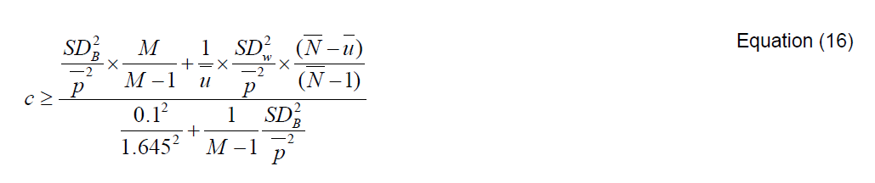
Where:
C | = | Number of villages that should be sampled
M | = | Total number of villages in the population
$$\overline{u}$$ | = | Number of households to be sampled within each village
$$\overline{N}$$ | = | Average households per village
SD_{B}² | = | variance between villages
SD_{W}² | = | average within village variation
p | = | Overall proportion
1.645 | = | Represents the 90% confidence required
0.1 | = | Represents the 10% relative precision

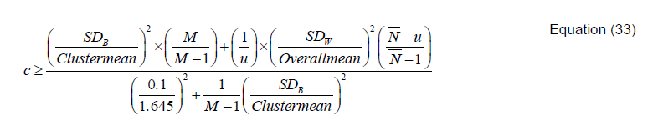
Where:
M | = | Total number of villages in the population
$$\overline{N}$$ | = | Average households per village
u | = | Number of households that have been pre-specified to be sampled per village
1.645 | = | Represents the 90% confidence required
0.1 | = | Represents the 10% relative precision
To achieve 90/10 confidence/precision, for B_{y=1,new,i,survey}, the minimum number of the sampled villages is 8; for N_{y,i,j}, the minimum number of the sampled villages is 2. As the project proponent and its local partner has surveyed 8 villages, the survey met the required 90/10 confidence/precision.
The Fuel Consumption Survey was conducted by local staff from 16/06/2023 to 24/07/2023, and the Project Survey, which including Usage Survey was conducted from 18/08/2023 to 24/01/2024. Please refer to the submitted spreadsheet “2_Data recording of Monitoring Survey” for details.
(b) Data has been collected
Besides the above parameters, the following data has been collected as per the applied methodology:
- Date of distribution
- Geographic location of the household who received the ICS
- Quantity of project ICSs distributed
- Name and telephone number, and address of received households
- unique identification ID for each ICS that is distributed
- Whether the cookstoves distributed under the project are being used
- Whether baseline stoves or other stoves are being used along with project stoves
The information collected will be stored in the electronic database for 2 years after the end of crediting period.
Quality assurance/Quality control
Training about monitoring plan has been provided to local staff of project proponent’s local partner, including survey protocol, method of data recording and analysis. The monitoring plan has been carried out by qualified personnel trained for quality assurance and quality control. The project proponent inspects local partner to confirm that the personnel are qualified and the monitoring plan has been properly implemented. The data collected has been cross checked by the project proponent.
The organizational structure for monitoring is shown as the bellow:

cooperate
Local partner
Project proponent
cross check data
design implement
Monitoring plan

(c) Implementation plan
The scope and objectives of the internal audit, including the processes or departments have been clearly defined. Then we developed an audit plan outlining the audit schedule, resources required, audit criteria, and responsibilities of audit team member. The main survey methods applied in the sampling plan include hardcopy questionnaires, online questionnaires, and face to face interview. The potential of refusals and other means of non-responses has been taken into account.
The audit team should classify and document non-conformities identified during the audit process, categorizing them based on severity and impact on quality, safety, or compliance. If they are in accordance with the applied methodology and other related rules, a change may be conducted in the validated monitoring plan. Otherwise, revision and improvement will be conducted in the monitoring. The related ERs will not be claimed in the monitoring report until the non-conformance has been corrected in the latter case.

Quantification of GHG Emission Reductions and Removals

Baseline Emissions
The applied methodology does not account for baseline emissions separately, but instead quantifies emission reductions as a function of the reduction in the amount of non-renewable biomass fuel consumption in the efficient project stoves as compared to baseline stoves. Please refer to Section 5.4 of the MR.

Project Emissions
The applied methodology does not account for project emissions separately, but instead quantifies emission reductions as a function of the reduction in the amount of non- renewable biomass fuel consumption in the efficient project stoves as compared to baseline stoves. Please refer to Section 5.4 of the MR.

Leakage Emissions
Leakage is considered as default 0.95 in accordance with the applied methodology.

GHG Emission Reductions and Carbon Dioxide Removals
The project activity replaces traditional wood-based stove with ICS, therefore net GHG emission reductions are calculated by applying Equations 1 and 2.
${ER}_{y}=\sum_{i}{\sum_{j}{{ER}_{y,i,j}}}$ Equation (1)
Where:
i | = | Indices for the situation where more than one type/model of improved cook stove is introduced to replace three-stone fire
j | = | Indices for the situation where there is more than one batch of improved cook stove of type i
$${ER}_{y}$$ | = | Emission reductions during year y in t CO₂e
$${ER}_{y,i,j}$$ | = | Emission reductions by improved cook stove of type i and batch j during year y in t CO₂e
${ER}_{y,i,j}=B_{y,saving,i,j}×f_{NRB,y}×{NCV}_{wood fuel}×\left({EF}_{wf,CO2}+{EF}_{wf,non CO2}\right)×N_{y,i,j}×0.95$ Equation (2)
Where:
$$B_{y,saving,i,j}$$ | = | Quantity of woody biomass that is saved in tonnes per improved cook stove of type i and batch j during year y
$$f_{NRB,y}$$ | = | Fraction of woody biomass that can be established as non-renewable biomass (f_{NRB}). The value is calculated to be 0.8746.
$${NCV}_{wood fuel}$$ | = | Net calorific value of the non-renewable woody biomass that is substituted or reduced (IPCC default for wood fuel, 0.0156 TJ/tonne)
$${EF}_{wf, CO2}$$ | = | CO₂ emission factor for the use of wood fuel in baseline scenario (IPCC default for wood fuel, 112 tCO₂/TJ)
$${EF}_{wf,non CO2}$$ | = | Non-CO₂ emission factor for the use of wood fuel in baseline scenario (IPCC default for wood fuel, 26.23 tCO₂/TJ)
$$N_{y,i,j}$$ | = | Number of improved cook stoves of type i and batch j operating during year y
$$0.95$$ | = | Discount factor to account for leakage
The quantity of woody biomass saved due to implementation of improved cook stoves is estimated by Equations 4 of the applied methodology:
$B_{y,savings,i,j}=B_{y=1,new,i,survey}×\left(\frac{η_{new,y,i,j}}{η_{old}}-1\right)$ Equation (4)
Where:
$$η_{old}$$ | = | Efficiency of baseline cookstove. The value is 0.1 based on baseline survey.
$$η_{new,y,i,j}$$ | = | Efficiency of the improved cook stove type i and batch j determined using Equation 5.
$$B_{y=1,new,i,survey}$$ | = | Annual quantity of woody biomass used by improved cook stoves in tonnes per device of type i and batch j, determined in the first year of the implementation of the project through a sample survey.
$η_{new,y,i,j}=η_{p}×{\left({DF}_{n}\right)}^{y-1}×0.94$ Equation (5)
Where:
$$η_{p}$$ | = | Efficiency of project stove (fraction) at the start of project activity; the value is 34% as per the specifications provided by manufacturer
$${\left({DF}_{n}\right)}^{y-1}$$ | = | Discount factor to account for efficiency loss of project cookstove per year of operation (fraction). This value may be based on actual monitoring or based on manufacturer’s declaration on expected loss in efficiency or through publicly available literature on relevant industry standards. Alternatively default value of 0.99 efficiency loss per year can be considered.
$$0.94$$ | = | Adjustment factor to account for uncertainty related to project cookstove efficiency test
As validated in the registered PD, the values of relative parameters below have been applied.
$η_{p}$=34%;
${DF}_{n}$=0.99;
Therefore, $η_{new,y,i,j}$ is calculated as below:
Age(y) | $$η_{new,y,i,j}$$
1 | 31.96%
2 | 31.64%
The project has distributed 24,696 ICSs to households during the monitoring period. According to the survey, there is only one household not use project ICS among the 160 sampled households. Therefore, the annual loss rate is 3/160. The usage rate is 157/160=98.13%.
Therefore, the${ N}_{y,i,j}$ is applied as below:
24,696 project ICSs have been distributed during this monitoring period, hence,
N_{y,i,j}=24,696*98.13%=24,232
$B_{y=1,new,i,survey}$=0.96 tonnes/device/year according to monitoring survey.
GHG emission reductions of the monitoring period is shown below:
Vintage period | Baseline emissions (tCO₂e) | Project emissions (tCO₂e) | Leakage emissions (tCO₂e) | Reduction VCUs (tCO₂e) | Removal VCUs (tCO₂e) | Total VCUs (tCO₂e)
06/08/2022-31/12/2022 | N.A. | N.A. | A discount factor of 0.95 is applied for leakage | 29,173 | 0 | 29,173
01/01/2023-31/12/2023 | N.A. | N.A. | A discount factor of 0.95 is applied for leakage | 79,471 | 0 | 79,471
01/01/2024-05/08/2024 | N.A. | N.A. | A discount factor of 0.95 is applied for leakage | 53,805 | 0 | 53,805
Total | N.A. | N.A. | A discount factor of 0.95 is applied for leakage | 162,449 | 0 | 162,449

Compare the estimated ex-ante GHG emission reductions and removals and the achieved emission reductions and removals for this monitoring period:
Vintage period | Ex-ante estimated reductions/  removals | Achieved reductions/  removals | Percent difference | Explanation for the difference
06/08/2022-31/12/2022 | 29,337 | 29,173 | 0.56% | There are three main reasons:  1. Due to a lack of funds, only 24,696 ICSs have been distributed during this monitoring period, which is the first two years of the project, and the project proponent planned to distribute 100,000 ICSs as described in registered PDD. The actual distribution quantity only counts about a quarter of the planned distribution quantity.  2. For ex-ante emission reduction calculation, it was assumed that 1.81tonnes/device/year. But the value applied in this monitoring period is only 0.96tonnes/device/year according to the survey, which is about 50% less than the former.  3. The average operation days of all devices during the first year of this monitoring period is 285.95, which only accounts 78.32% of one whole year.
01/01/2023-31/12/2023 | 306,773 | 79,471 | 74.09%
01/01/2024-05/08/2024 | 343,644 | 53,805 | 84.34%
Total | 679,754 | 162,449

APPENDIX 1: STATEMENT ABOUT OUTCOMES OF SDGS
Statement from MANIRISOA SERVICE INTERNATIONAL which is the implementer of the project.
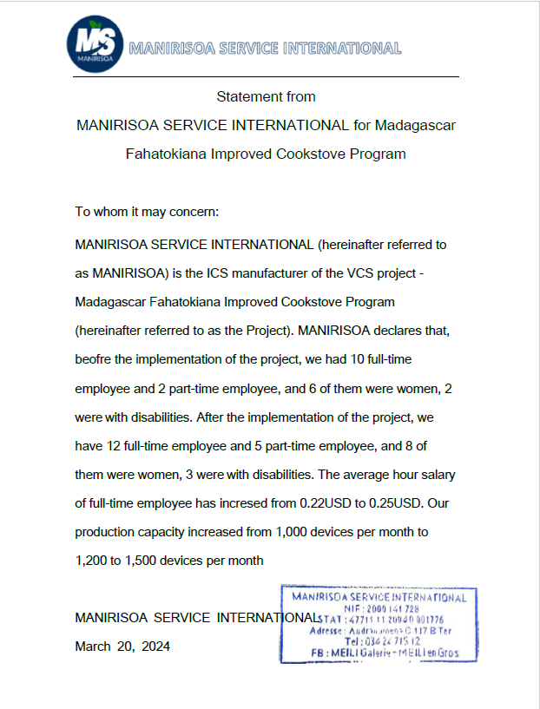

Projects, activities, or methodologies may be developed under any of the 16 VCS sectoral scopes: https://verra.org/programs/verified-carbon-standard/vcs-program-details/#sectoral-scopes
https://www.fao.org/3/I9967EN/i9967en.pdf
Compared between baseline survey and monitoring survey, the result is calculated in Grid AU165 and AY165 of the submitted spreadsheet “2_Data recording of Monitoring Survey”.
The result is recorded in Grid B25 of the submitted document “1_MR-ER calculate sheet”.
Please refer to appendix 1 “Statement about outcomes of SDGs”
Please refer to appendix 1 “Statement about outcomes of SDGs”.
AMS II.G. Version 11
2006 IPCC Guidelines for National Greenhouse Gas Inventories; Chapter 2 Stationary Combustion
2006 IPCC Guidelines for National Greenhouse Gas Inventories; Chapter 2 Stationary Combustion

